Blakehurst/Mission Helpers Update Zoom Meeting – Tuesday 8th June, 2021
Hosted by Blakehurst: Mr. J Ross Nichols & Ms. Patricia Malone

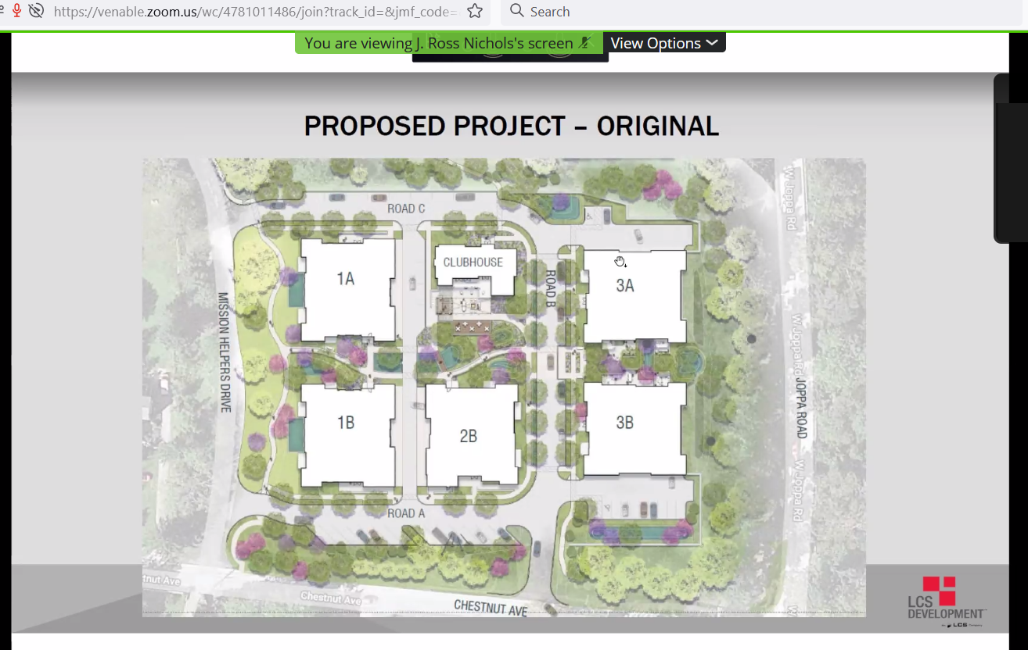

Every unit is a corner unit; units NOT for sale – an entrance fee and monthly service fee (dining, utilities, fitness center, access to health center…)
Triangle signals front entrance to the structure. Clubhouse is a one story structure

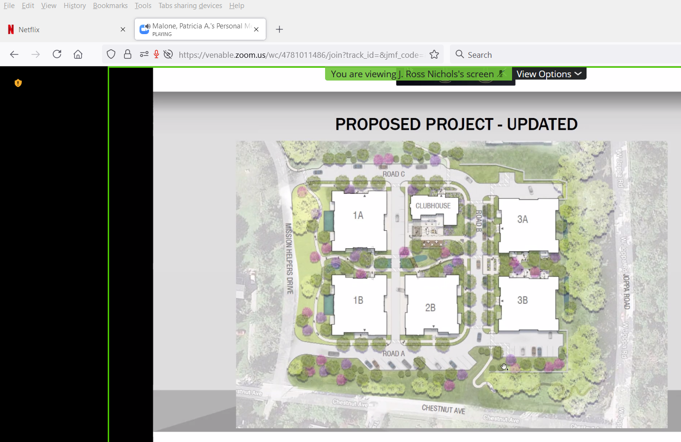Baltimore County said developer could eliminate Chestnut Ave entrance

Comparison of greenscape:

No longer need to request a variance for the 75 foot buffer on Chestnut Avenue because buildings set back sufficiently. This graphic shows old idea of driveway from Chestnut which is now gone.

40 internal parking spaces and 37 outside (mainly for day-time care givers or relatives). Rarely do the residents have second cars and try to discourage this.
Lot of shared services regarding employees. Have to hire another housekeeper or two and perhaps maintenance person; keep same marketing department. This is meant to be a continuation of Blakehurst. Will not be parking in this area; still up at the main campus/main entrance to Blakehurst.
Two means of in/out for the property
Mail will be in Blakehurst
Leaning towards having full access to Blakehurst facilities.
Will be asking the county to change the restriction of 54 people in the 40 units.
Residential transition area – none of the buildings violate the residential transition area, per Patsy Malone.
Hope Jordan - RRLRAIA
Jeffrey Budnitz - RRLRAIA
Rudi & Marcella Bayer (own property corner Trafalgar & Chestnut)
Dr. Bill Ashley – 620 Chestnut
Mark Heckman

