Mission Helpers – Community meeting Thursday 11th February, 2021, via zoom (7 p.m.)
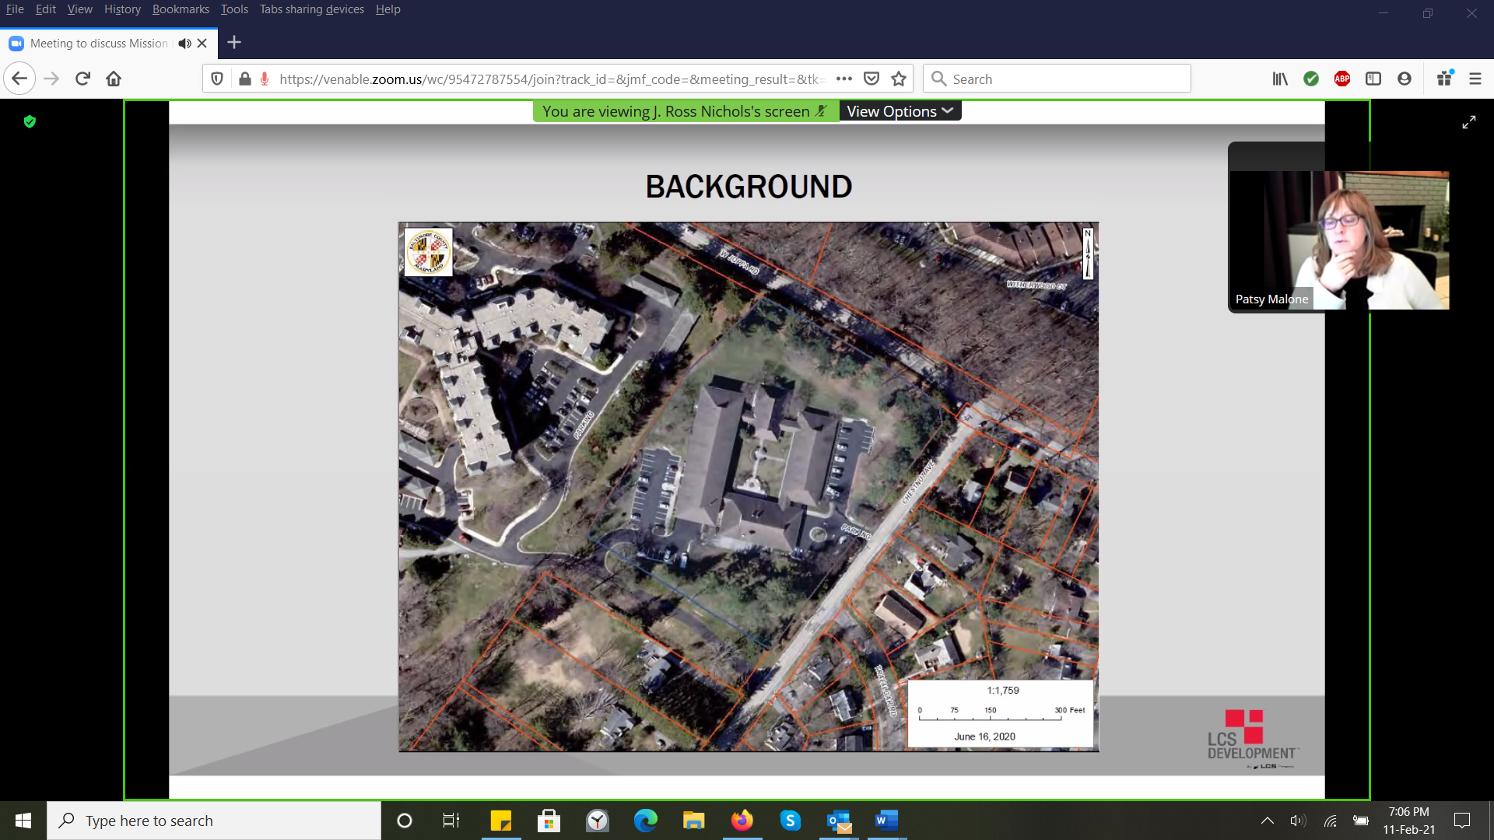

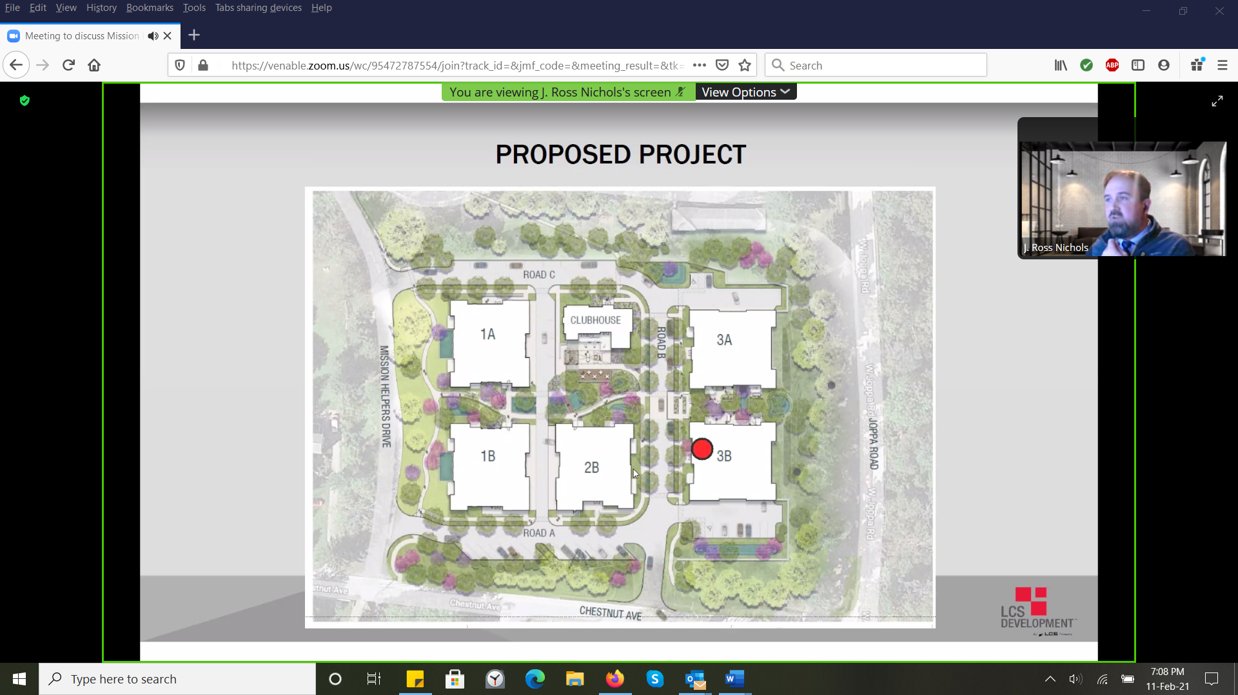
Put residences on each of the corners. Forty units total.
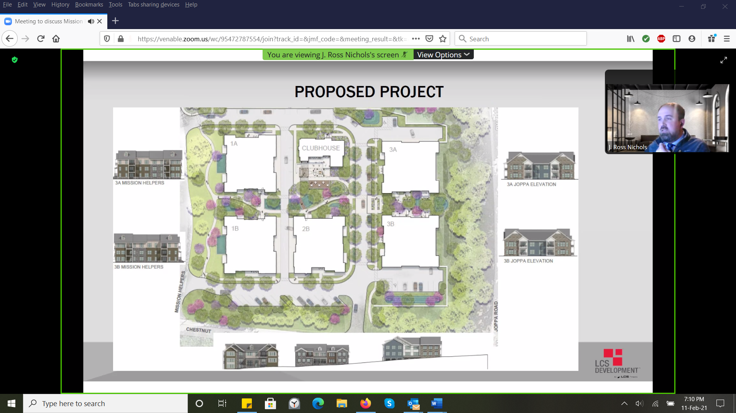
Surface parking for visitors and guests
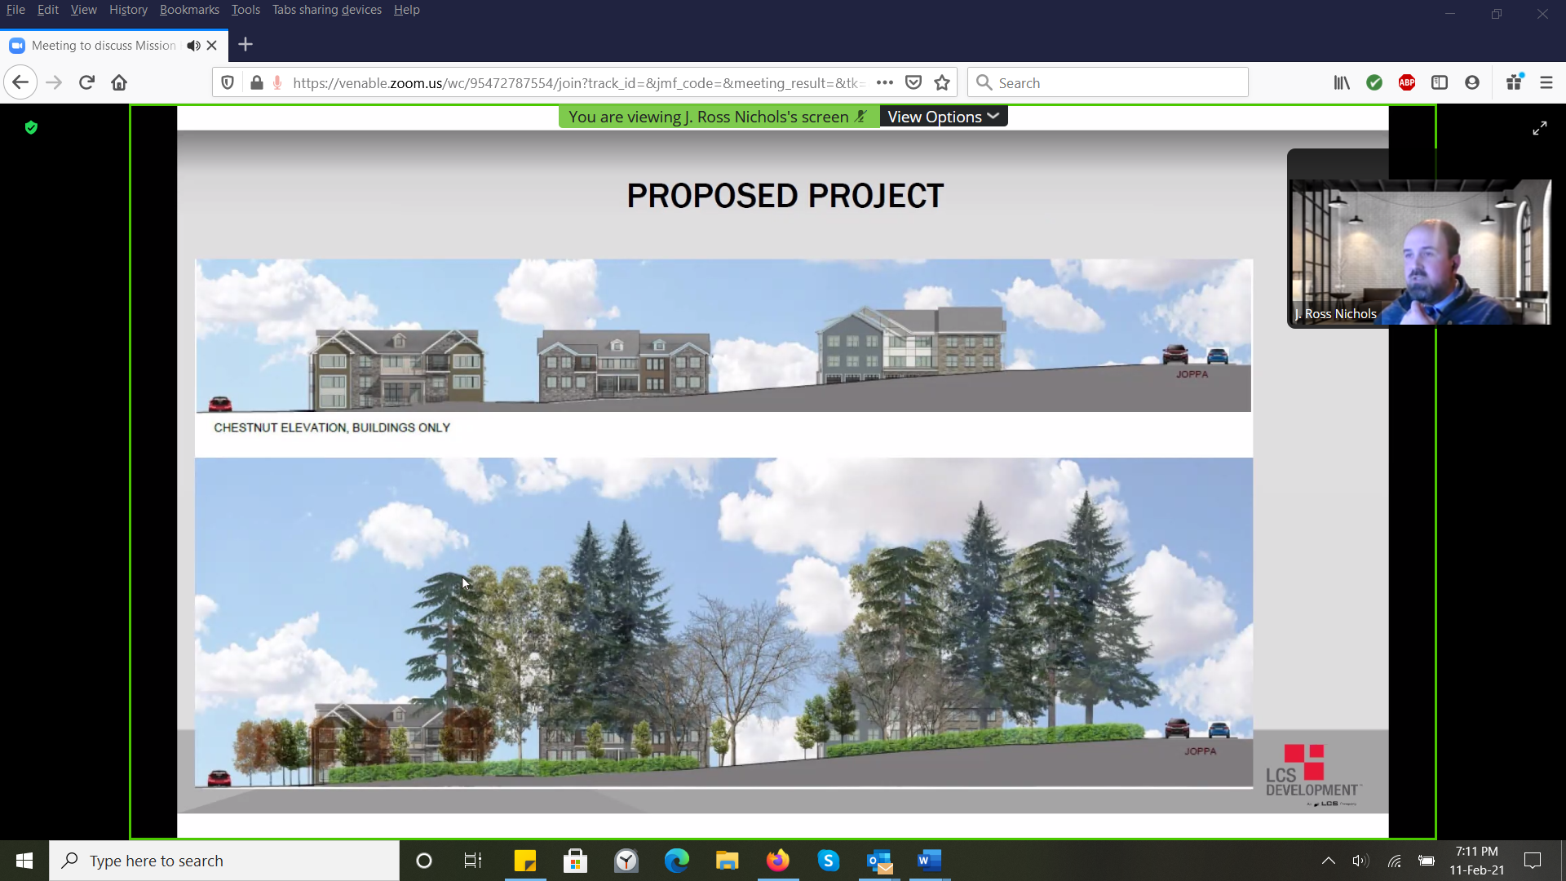
View from Chestnut Avenue (top – removed all vegetation / bottom – with existing mature trees plus new plantings (on left)

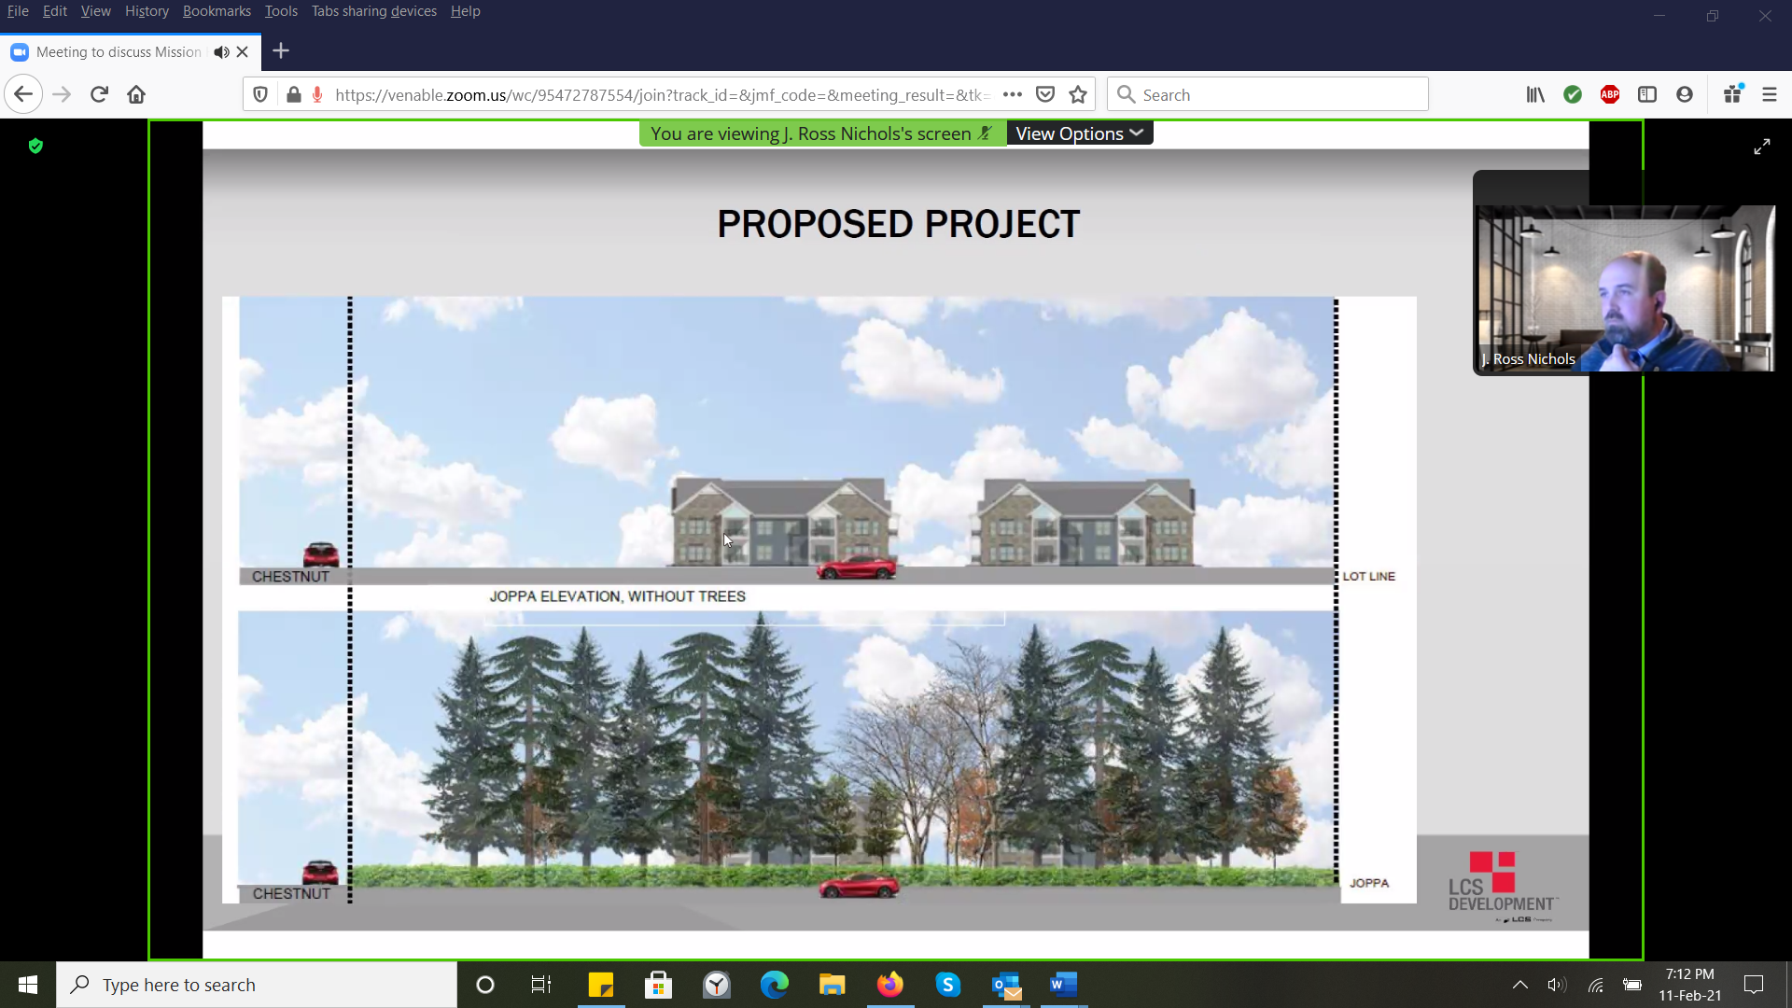

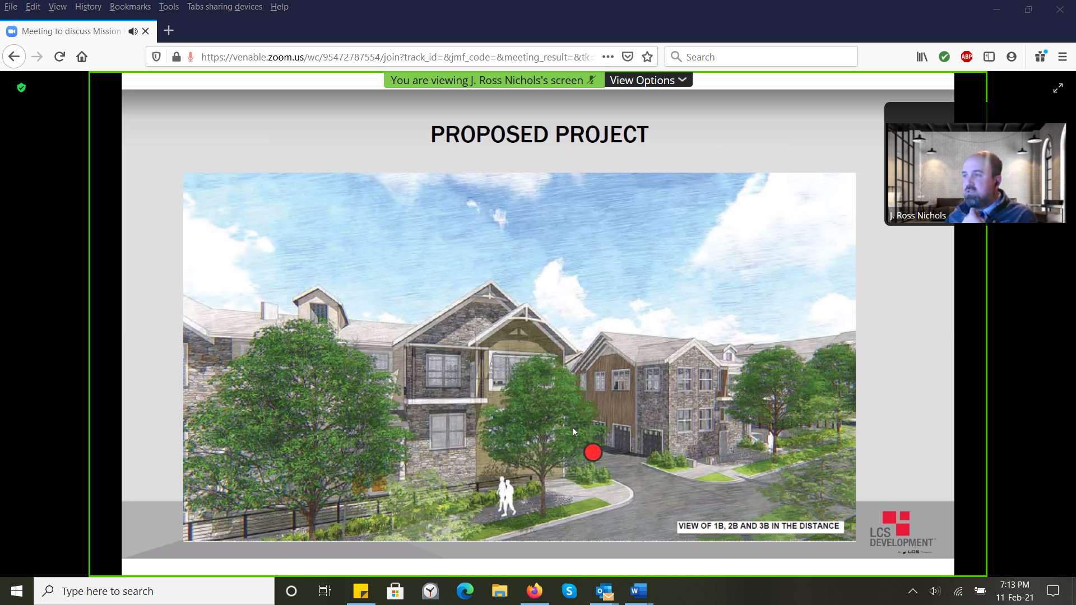
Looking from Chestnut Avenue
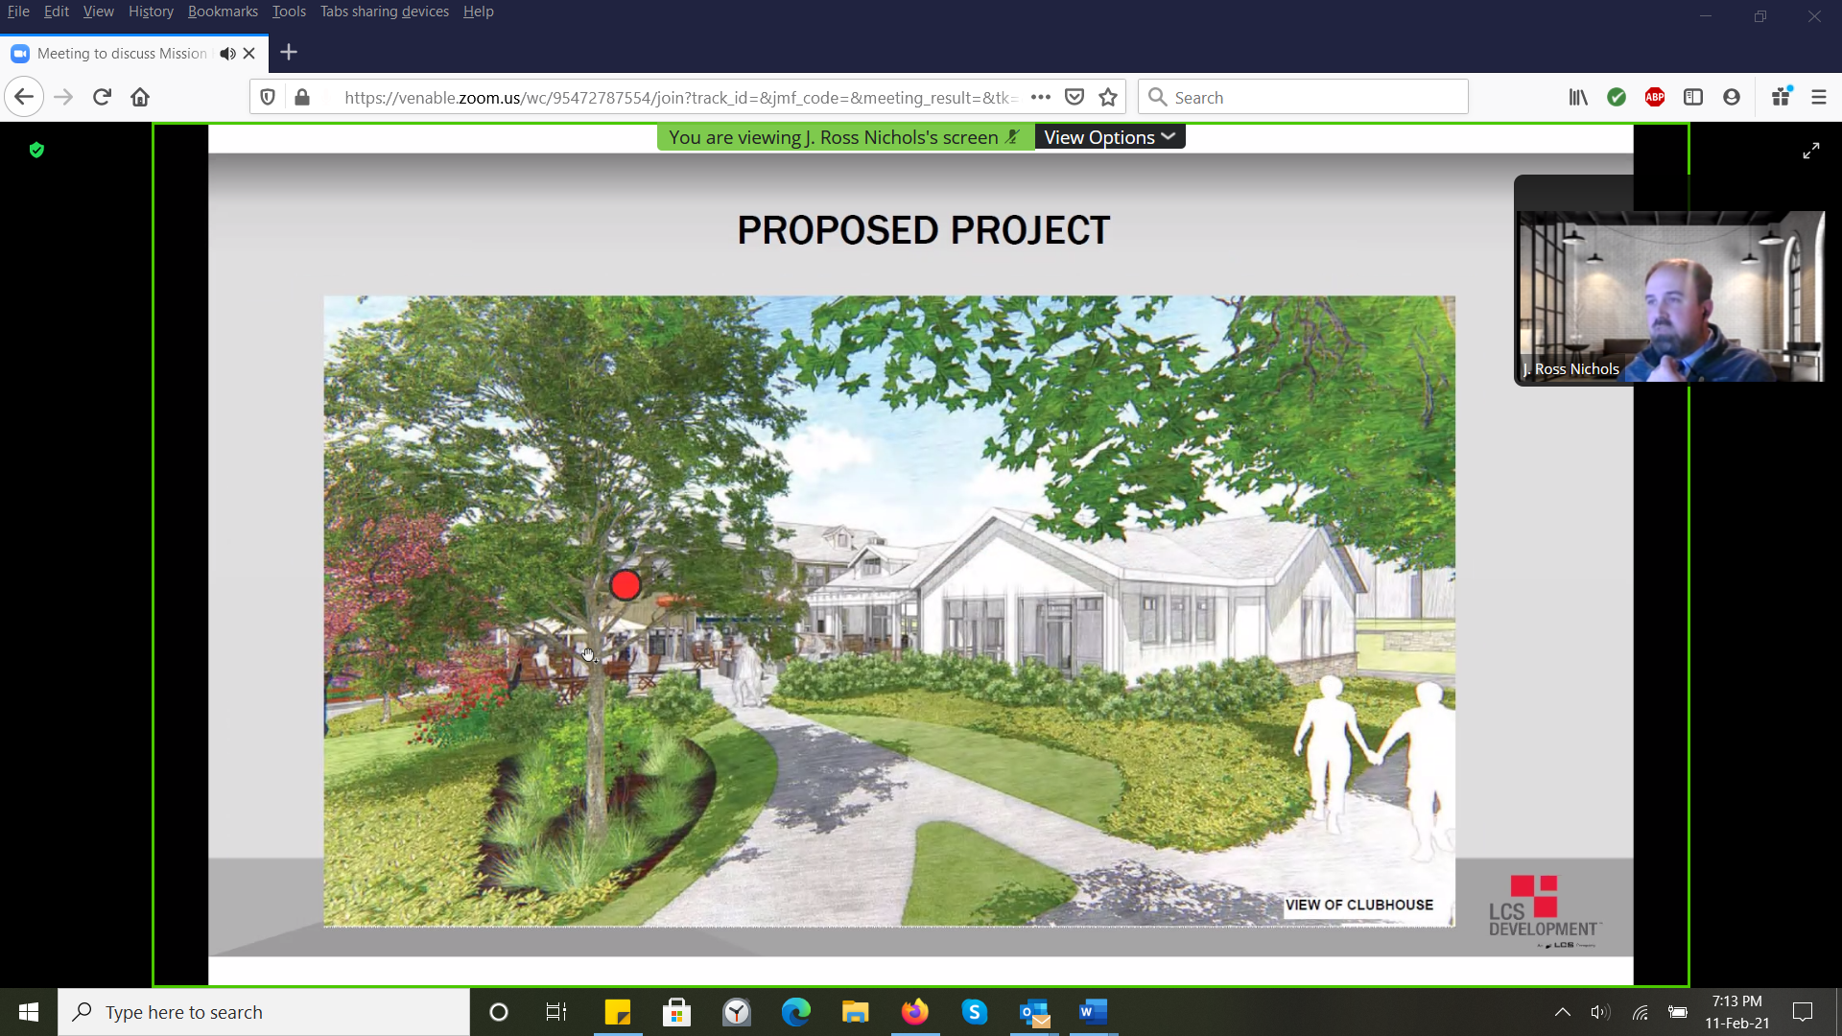
Club house
Club house
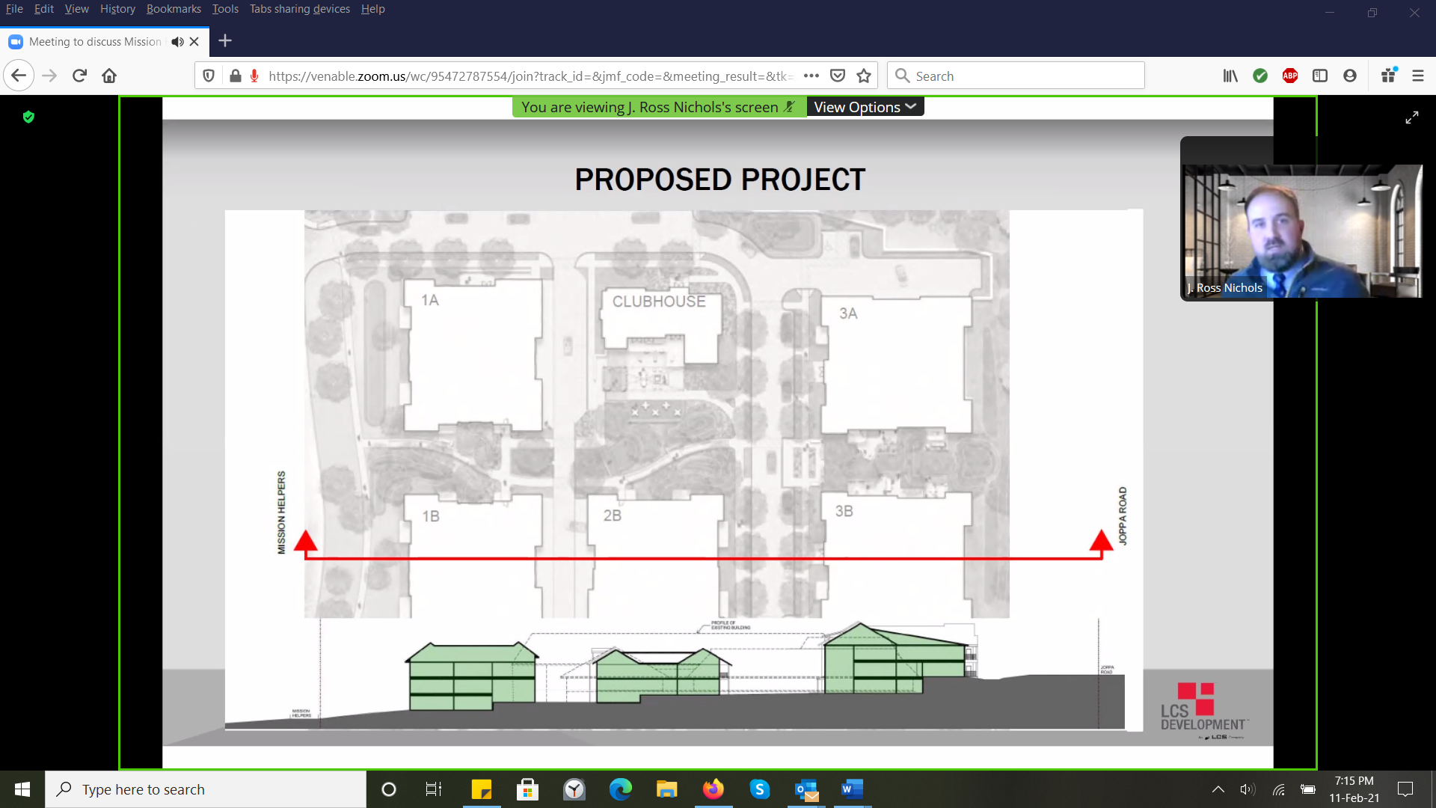
Dashed line at bottom of picture is existing Mission Helpers building
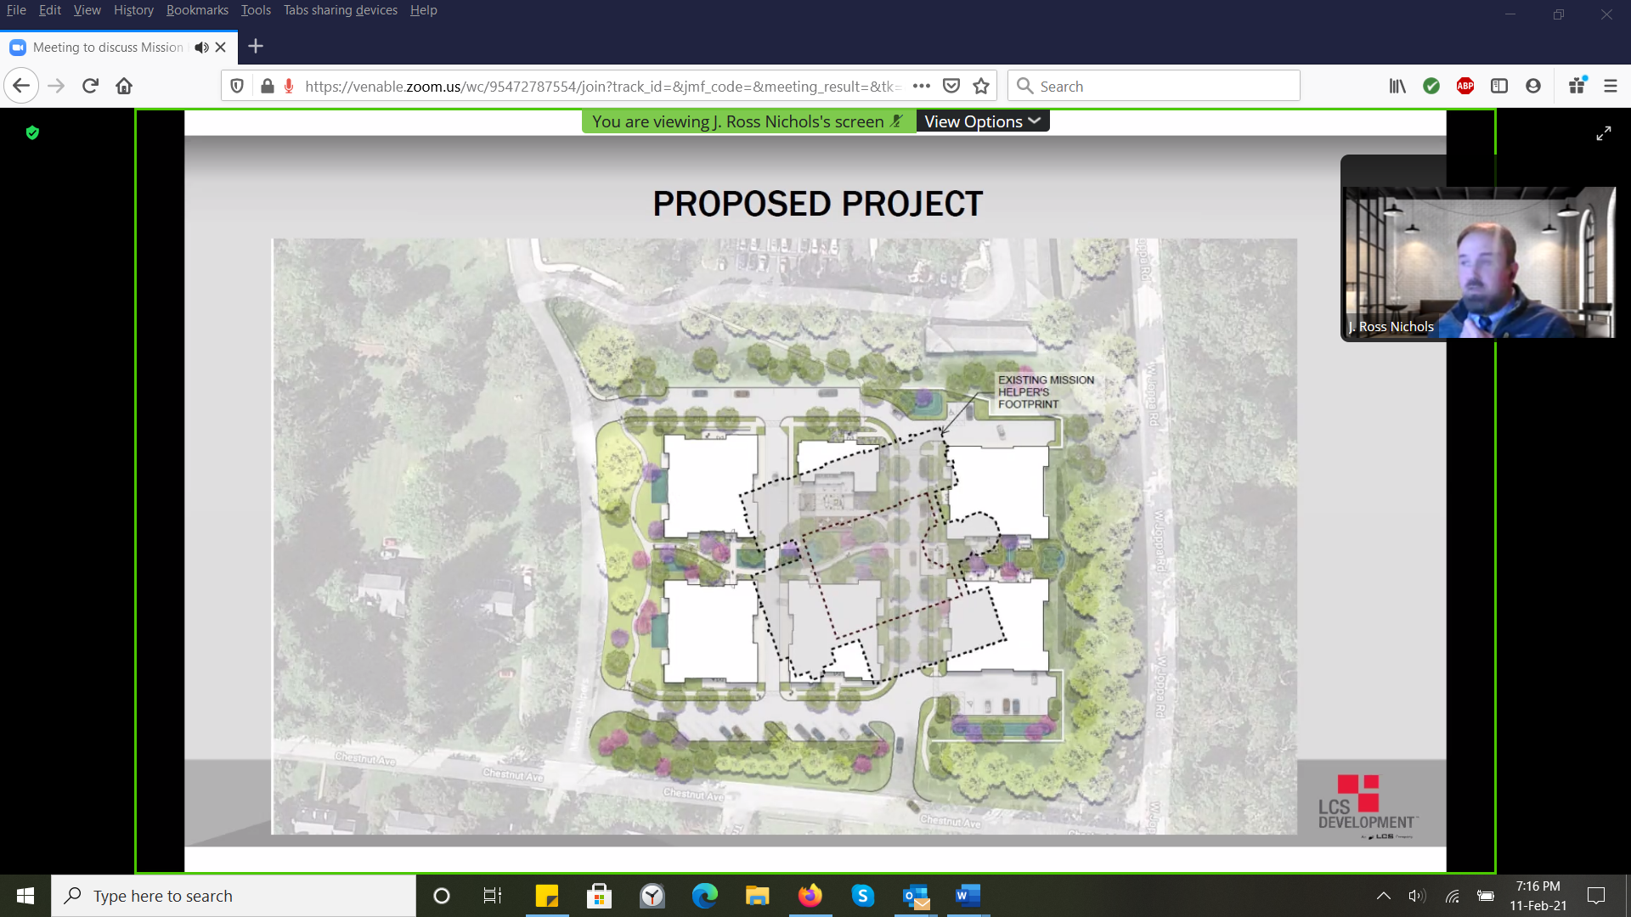
Dashed line shows existing MH building
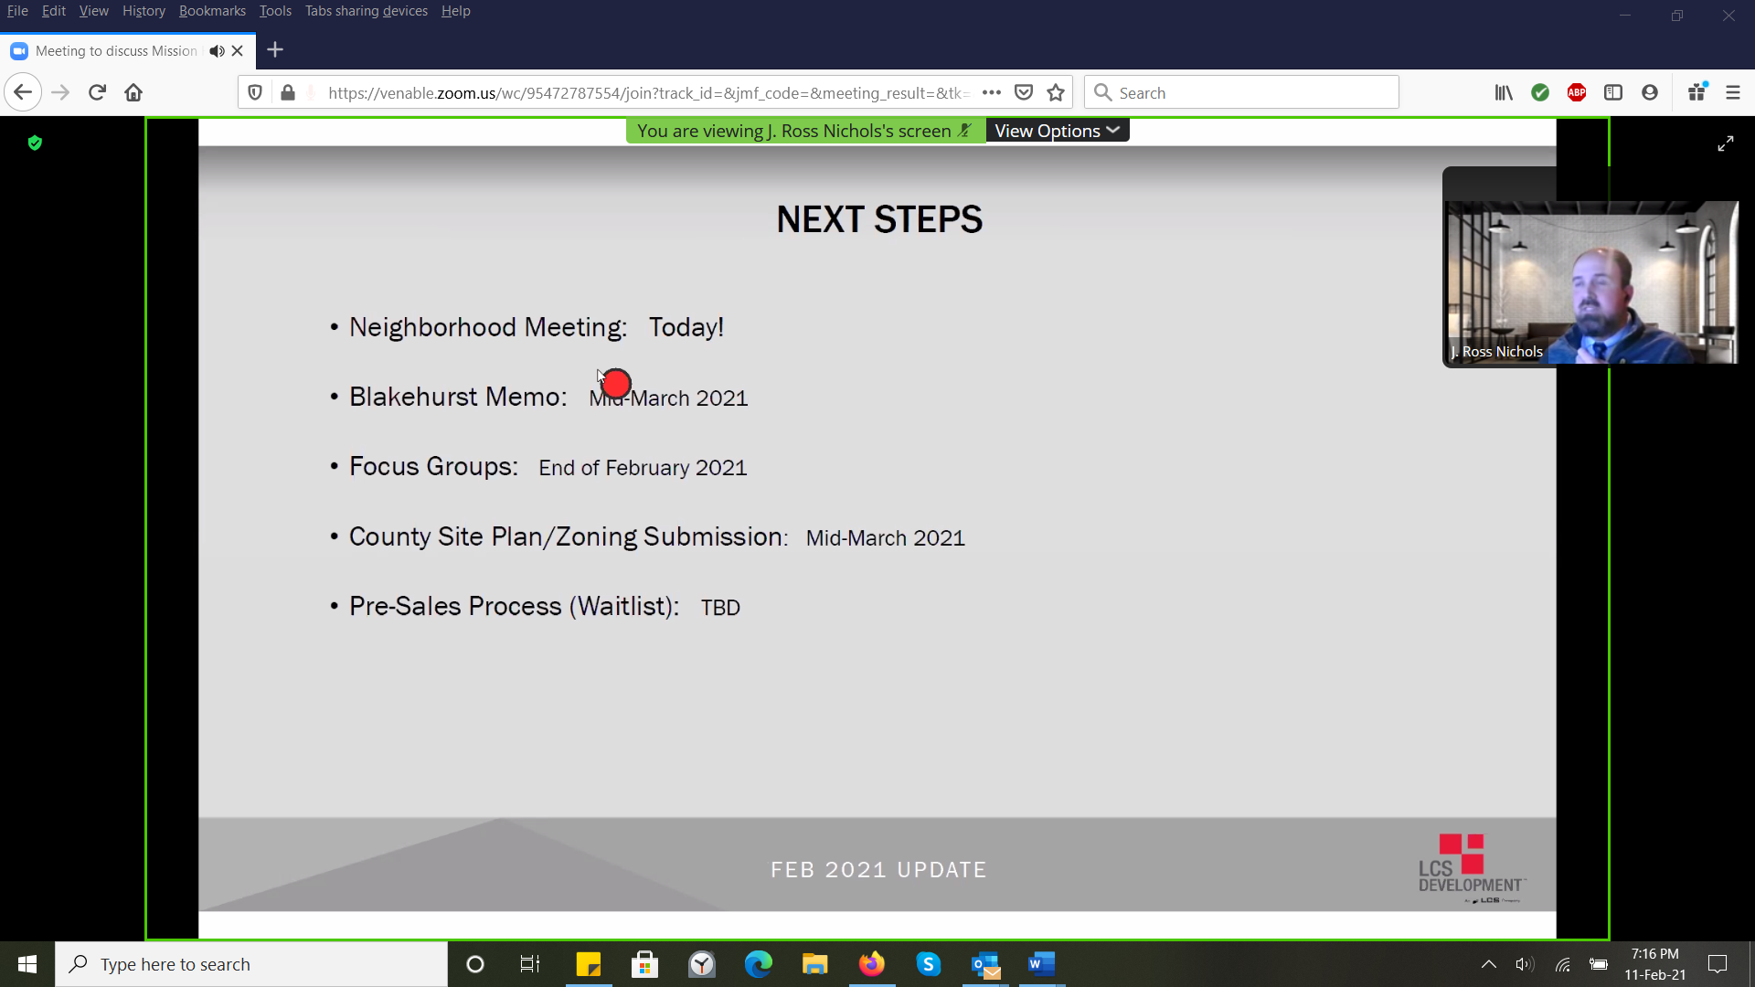

40 spaces in garages; 47 surface parking spaces. 1500 to 2200 square feet for the units (proposed at this point; could change)

